
Recliners
USER’S MANUAL

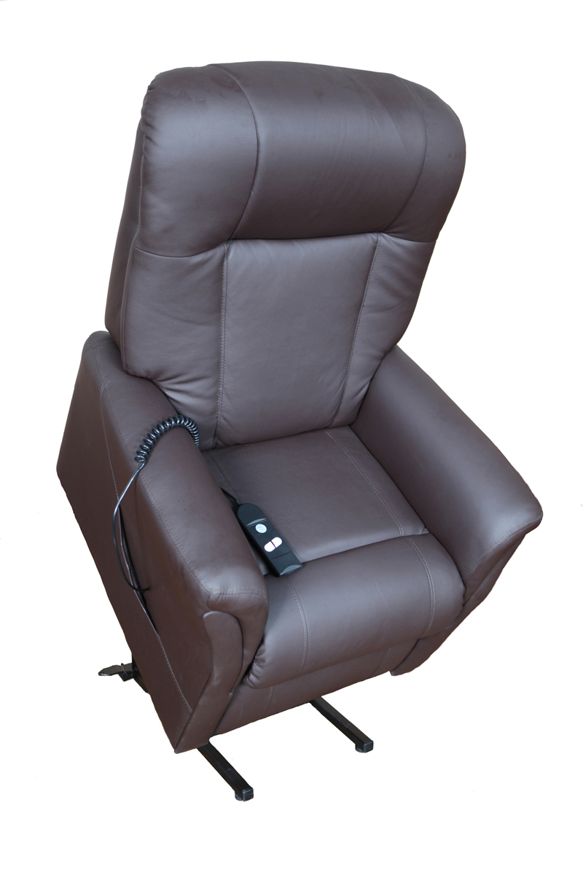

DEALER: This manual MUST be given to the user of this product.
USER: BEFORE using the electrical lift chair, read this manual and save for future reference.
INTRODUCTION:
This is an electrical Lift chair designed to help people to rise easily from the chair.
Please read the operation manual thoroughly for the correct methods of usage, especially the notes on Safety.

This manual should be kept available for future reference after you have read it through.

CAUTION!
DO NOT attempt to adjust or operate the electrical lift chair without carefully reading
and understanding all instructions in this manual.
Check ALL parts for shipping damage before use. In the case of shipping damage, DO
NOT USE. Please contact your healthcare provider for further instruction.
If you are unable to understand the warnings, cautions or instructions, contact a
healthcare professional, dealar or technical personnel before attemting to install this
equipment-Otherwise, injurty or damage may occur.
The user should ALWAYS consult with his/her physician or therapist to determine proper
adjustment and usage.

CONTENTS:
Safety-------------------------------------------------------------------------------------------------- 4

Specifications---------------------------------------------------------------------------------------- 7

Assembly--------------------------------------------------------------------------------------------- 8

Placing of the Chair-------------------------------------------------------------------------------- 11

Usage-------------------------------------------------------------------------------------------------- 12

Product Care and Storage------------------------------------------------------------------------ 14

Limited Warranty----------------------------------------------------------------------------------15

SAFETY:
- Warning
The chair must be assembled correctly according to the Assembly instruction enclosed.
The manufactures of the chair, their agents and distributors are not liable for any
damages caused by improper assembly of the chair.
The chair must be placed on a flat floor level.
DO NOT use your Chair in humid or dusty environment, as it may cause electrical
shock or machine trouble. The chair must be in a dry room.
DO NOT use your Chair in room temperature higher than 40℃.
DO NOT expose your Chair to heaters, stoves or direct sunlight.
DO NOT use the chair outdoor. Indoor Use Only. Avoid exposure to rain, snow, ice,
salt, or standing water. Maintain and store in a clean and dry environment.
When the chair is NOT in use, disconnect the power cord from the main supply to
avoid overheating.
DO NOT rest or place any heavy object on the armrest, footrest, back of the chair.
Pinch/Crush Points- Prevent personal injury and equipment damage. DO NOT place
appendages or objects in path of moving parts.
DO NOT jump or play on the chair.
DO NOT sit or stand on the footrest.
DO NOT sleep on the chair during operation.
Children must be supervised by an adult when using the lift chair, This chair is NOT
intended for children.
Keep pets away when lift chair is in motion.
Keep all parts of your body clear of the lift and scissor mechanism.
Check that the voltage corresponds with the specifications indicated for the chair.
Electrical connection must be made in accordance with local regulation.
DO NOT disconnect the plug from the electrical outlet roughly.
DO NOT connect or disconnect the plug from the electrical outlet with wet hands. It
may result in electrical shock or machine troubles.
When disconnecting the plug, pull it out by holding the plug and not by the cord.
DO NOT place the AC/DC adaptor cord under the Chair as it may damage the cord
and result in fire or electrical shock.
DO NOT let the AC/DC cord hang down from the chair.
DO NOT use the Chair if the AC/DC cord or plug is damaged, or if the electrical outlet
is excessively loose. Contact the professional for inspection.
Prevent personal injury and equipment damage. DO NOT connect an extension cord to the
AC/DC converter or the battery charge.
If necessary the power cable may be replaced with an identical one, which must only
be replaced by a qualified technician.
DO NOT touch the surface of the plug immediately after use, as it can be very hot.
DO NOT operate the remote control with wet hands, sharp or heavy objects.
DO NOT drop the remote control.
DO NOT step or place heavy objects on the remote control wire.
DO NOT put your fingers and hands in between the seat and the footrest, when the
chair is reclining or when the chair is returning back from the recline position to sit
position. You may hurt your fingers/hands badly.
DO NOT modify, add, remove, or disable any feature, part, or function of your lift
chair. Contact your authorized dealer for all repairs and replacements. Unauthorized
modifications may result in personal injury and/or damage to your lift chair.
Modifications will result in a voided warranty.
This Chair must be used in accordance with the instruction provided.
This Chair is NOT for professional use.
The manufacturers of this chair, their agents and distributors are not liable for any
damages to person(s) or property(s) resulting from improper and misuse of the Chair.

Note: All repairing must be done by qualified technician or the After Sales Service.

Caution:
Should you use the Chair in a cold room, do not increase the room temperature abruptly. It is recommended that you increase temperature gradually to a normal level. In the event that the Chair is stored in a cold place and is being brought into a warm place, it is advisable to use it one hour later, This is because its performance may not be at its optimum level as it may have dew on the mechanical parts. Machine trouble may be resulted when a cold machine is being used in a warm room suddenly.

- When the Chair Should Not Be Used
In the following events, please switch the power OFF immediately and disconnect the AC power cord from the electrical outlet. Contact a professional for servicing.
If the Chair is accidentally spilt with water. This may result in electrical shock.
If the upholstery is torn and the inside mechanism are exposed.
If you detect any main function or other abnormal condition during operation.
If there is a power failure, injury may be caused when power is restored
unexpectedly.
If there is severe lightning

Note: Check for tears to the Upholstery Cloth regularly

SPECIFICATION :
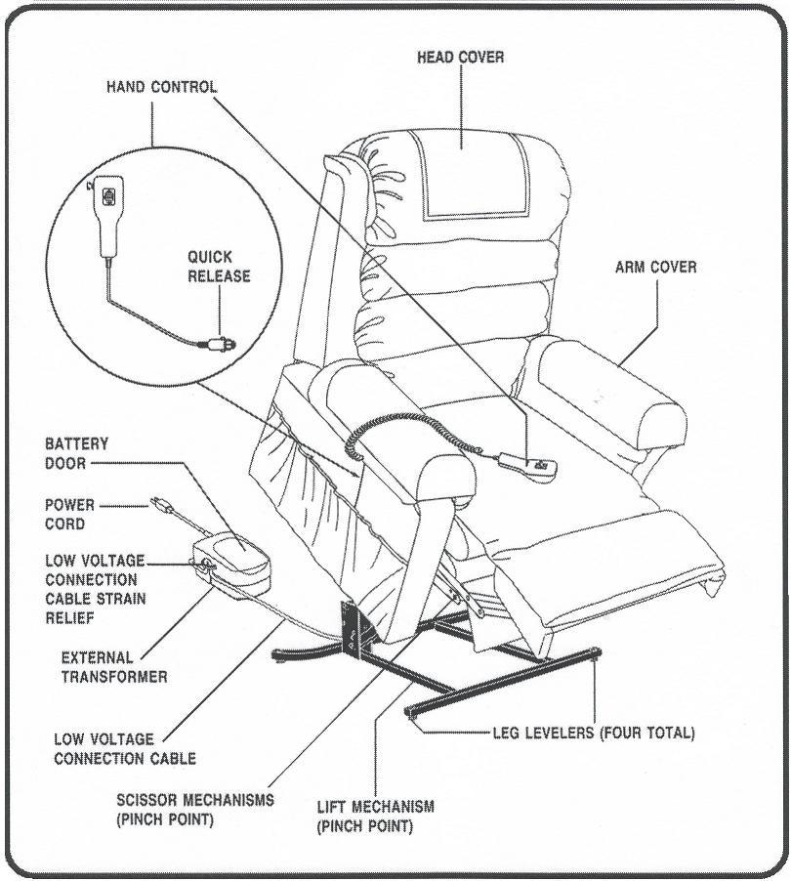
Warning! Exceeding the weight capacity vois your lift chair warrant and may
result in person injury and/or damage to the lift chair.
Warning! Prevent the risk of electrical shock, fire, falls and/or being pinched.
Follow all instructions provided. Failure to heed could result in personal injury
and/or damage to the lift chair.

Weight - The weight of the chair is 133 lbs.
- Weight Capacity is 350 lbs.

AC 100-240
Power - DC 29___ V ~ 50 Hz 70 W

Operation Temperatures: -10۫C / 50۫F to 40۫C / 104۫F
Note:
Motor-Operation, 2minutes is available for continuity use, spacing time percentage 10%
ASSEMBLY:

The chair is packed in semi knock down form consisting of the back and the seat. Assemble
the chair according to the instructions given in the Assembly Instruction section.

Assembly Instruction:
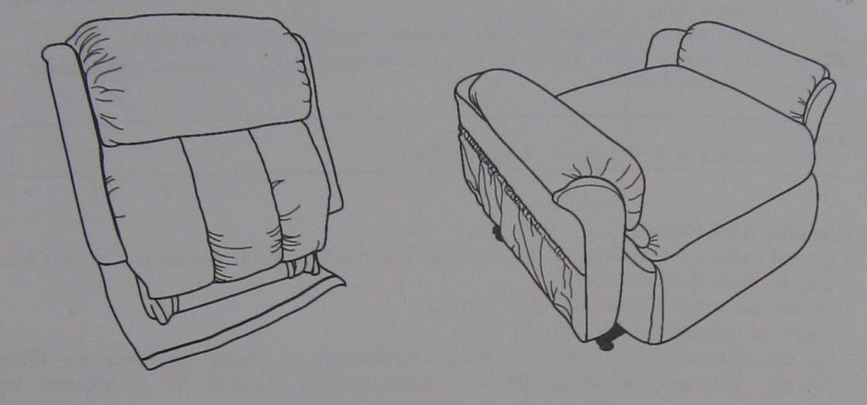
Note: DO NOT assemble the chair if any of the parts of the chair are damaged. Check all parts carefully before assembling the chair. If any problem return to vendor.

Step 1:
The chair is packed into two packages (chair base and chair back). Please remove them and the accessories bag from the packages.

Step 2:
Take out 4pcs leg levelers and 4sets of wheels from the accessories bag.
a. Install leg levelers on the chair frame. (Figures 1, 2 & 3)
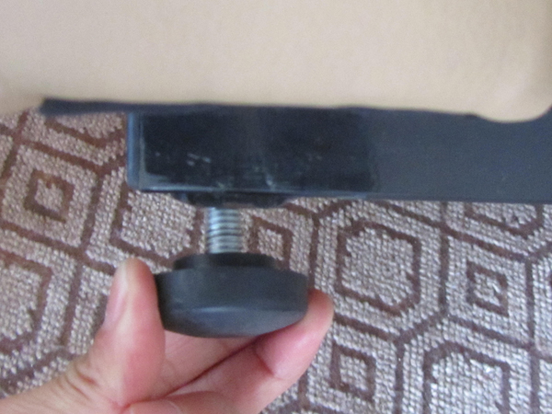
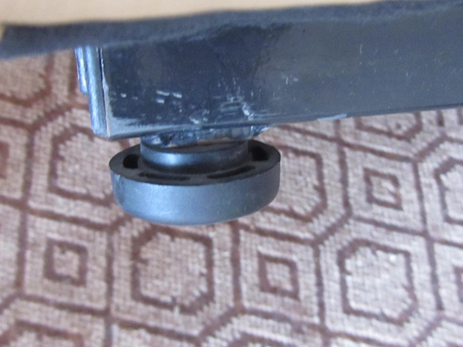
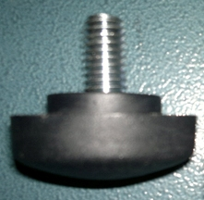

(Figure 1) (Figure 2) (Figure 3)

b. Install wheels on the chair frame. (Figure 4, 5 & 6)
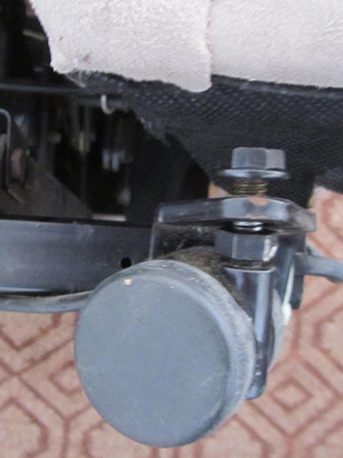
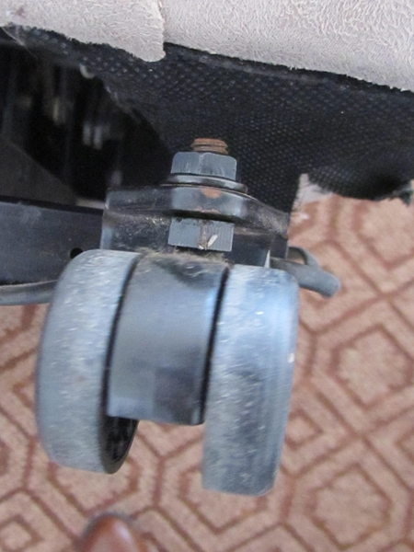
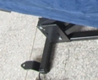

(Figure 4) (Figure 5) (Figure 6)
Step 3:
Put the chair back on top of chair base. (Figure 7)
Make sure the metal bracket slips into the metal bracket of the chair base. (Figure 8)
Press the metal brackets until you can hear the “click” sound when the metal bracket is installed properly. (Figure 9)
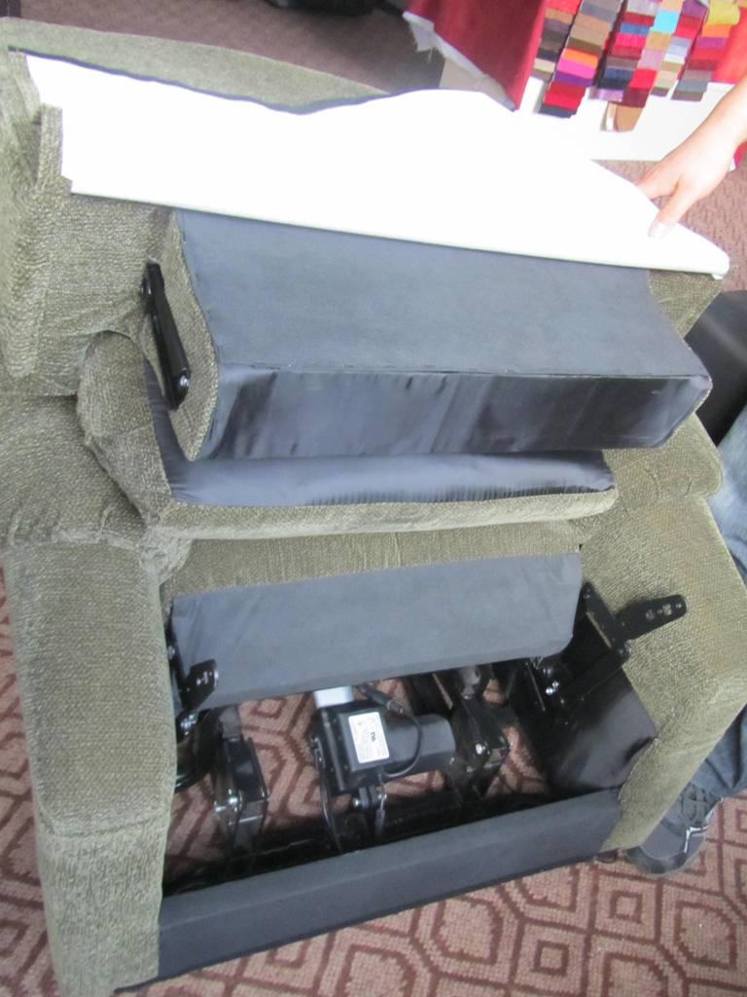
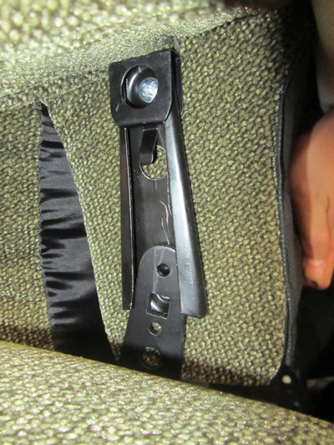
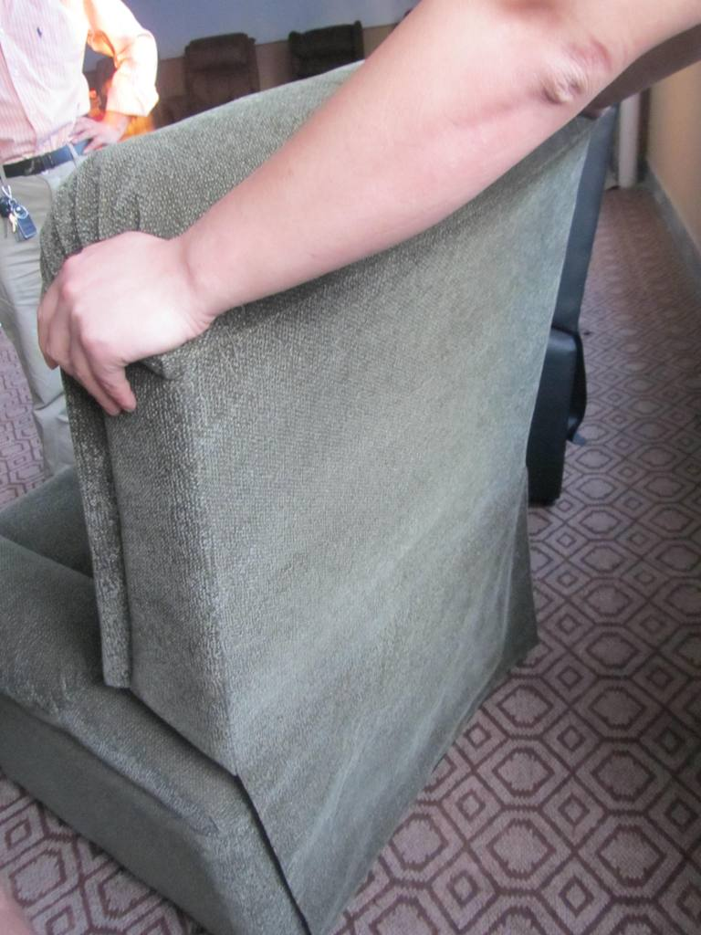

(Figure 7) (Figure 8) (Figure 9)

Step 4:
Find the motor wire under the chair base. (Figure 10)
Connect the adaptor with the motor wiring and then connect the plug wiring with the adaptor. (Figure 11 & 12)
Take the hand control out from the side pocket of the seat. (Figure 13)
The assembly is finished, and you can start to use the lift chair.
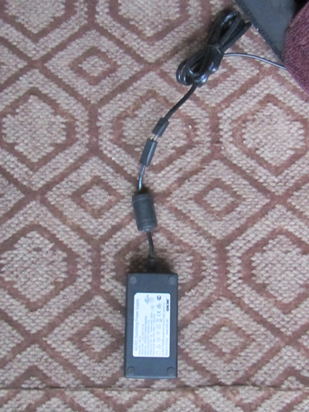
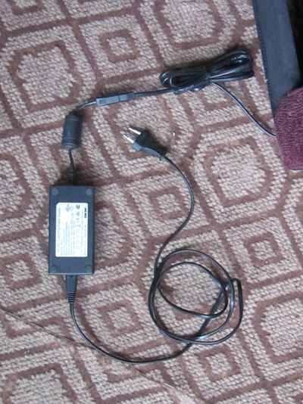
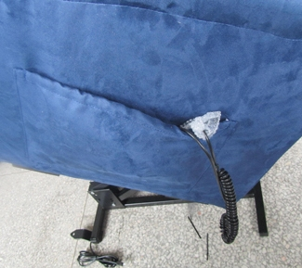
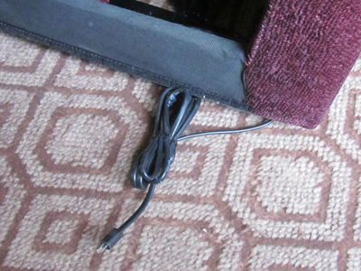

(Figure 10) (Figure 13)
(Figure 11) (Figure 12)

Once the chair is assembled as per Assembly Instruction, place the chair on a flat surface in a dry room. The chair is now ready for use.

Note: Make sure all the wires are properly connected, if not the chair will not function properly.
If the external transformer or hand control is damaged, immediately place it in a
plastic bag and call your authorized dealer for instructions on disposal. Recycling is
always recommended. Properly dispose of batteries per manufacturer’s instructions.
Electromagnetic and Radio Frequency Interference (EMI/RFI)
Per EMC standards, this lift chair is suitable for use in all establishments including domestic
establishments and those directly connected to the public low-voltage power supply network
that supplies buildings used for domestic purposes. This product has passed immunity testing.
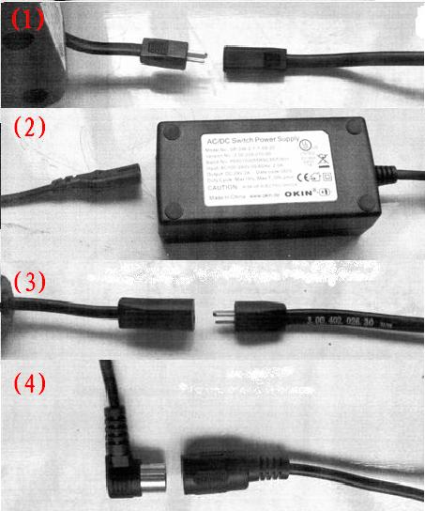

(1) Connector for the motor and wiring.
(2) Connector for wiring and adaptor.
(3) Connector for adaptor wiring and plug wiring.
(4) Connector for the motor and the hand control.

PLACING OF THE CHAIR :
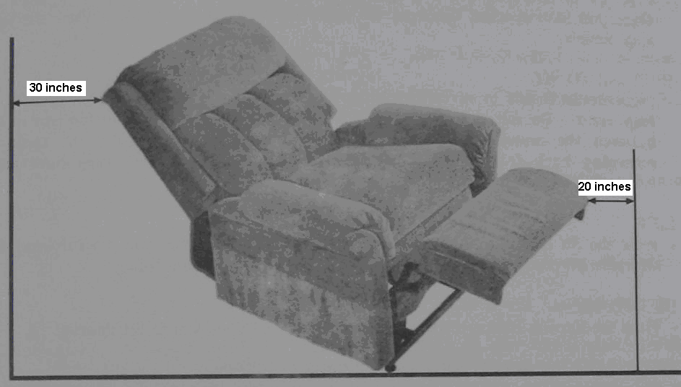

- Allow sufficient space in front of and behind the chair for reclining purpose.
- Make sure there is an allowance of more than 30inches behind the Chair and more than 20inches in front of the Chair.
- Place the chair near a properly wired standard wall outlet.
- Place the chair on a flat surface/floor in a dry room.
- Adjust the leg levelers to keep the chair stable.
- Turn the leg levelers clockwise to raise the chair and counter-clockwise to lower the chair.
- Lay the low voltage connection cable, located at the back of the chair, where it will not be pinched between the wood frame and the lift mechanism. If the low voltage connection cable is not already connected to the external transformer, connect it at this time.
- Ensure the external transformer, power cord, and the low voltage connection cable are not damaged or wet.

Caution:
- Make sure there is no obstruction behind or in front of the Chair for a safe recline and lift during operation.
- Plug the electrical chord directly into the outlet. DON’T use an extension cord!
- No finger or object should be placed between the Chair and the Footrest.

Warning!
Before attaching back of the Lift Chair, place hand control in center of cushion.
Improper hand control cable routing can lead to equipment damage & malfunction.

USAGE :

RECLINE
  - Press the Recline Button and the chair will recline.
Once you have reached the desirable position release the button and chair will stop reclining.

RECLINE TO SIT
  - Press the Sit Button to return the chair from the Recline position to the Sit position Important: Do not put your hands in between the seat and the footrest or in between the metals parts when the chair is reclining or when the chair is returning back from the recline position. You may hurt your fingers/hands badly.

- LIFT
  - Press the Sit Button to lift the chair from Sit position. Once you have reached the desirable Lift position release the button and the chair will stop lifting.

- LIFT TO SIT
  - Press the Recline Button to return the chair from Lift position to Sit position.

- TO SIT AND STAND
  - Depress and hold the up/down switch in the “↑” position to raise your life chair to the standing position. Back into the lift chair and sit in the center of the seat. Use the arms of the lift chair for support if needed.
  - Depress and hold the up/down switch in the “↓” position until comfortable.
  - To return to the standing position, push and hold the up/down switch in the “↑” position. The lift chair will begin to rise. Release the switch when the lift chair reaches a height where you can stand up comfortably.

- TO SIT AND RECLINE
  - Depress and hold the up/down switch in the “↓” position to the reclining position until comfortable.
  - Depress and hold the up/down switch in the “↑” position to return your lift chair to the sitting position.
  - To return to the standing position, push and hold the up/down switch in the “↑” position. The lift chair will begin to rise. Release the switch when the lift chair reaches a height where you can stand up comfortably.

- THERMAL SHUTOFF
  - Your lift chair is equipped with an internal thermal shutoff switch located inside the external transformer that prevents the motor control box from overheating. If the motor stops during lifting cycle, allow the lift chair to remain in this stationary position for 10 minutes. This will allow the motor control box to cool down and reset itself. After cooling down, normal use of your lift chair can resume. If you notice frequent overheating, contact your authorized dealer.

- BATTERY BACKUP
  - During a power failure, your lift chair’s battery backup system will automatically activate. This system is designed to take you from the recline position to the sit position only. Your battery backup system is powered by two 9V alkaline batteries (not included).

  - Always make sure your lift chair’s battery backup system is equipped with two fresh 9V alkaline batteries, since the system does not recharge itself. Fresh batteries are defined as 9V alkaline batteries that are replaced every time the battery backup system is activated during a power failure, or once a year if the battery backup system has not been activated.

  - If you unplug your lift chair for an extended period of time(more than one hour), remove the batteries. The lift chair will draw power from the batteries even when it is not in use.

Caution:
- When sitting down in your chair, never “drop” into chair if it is partially raised.
- The external transformer is packaged independently of your lift chair. Please DON’T discard any packaging before locating the external transformer.
- Make sure the external transformer is plugged into a properly wired outlet and check the circuit breaker box.
- Make sure the connection cable from the chair is properly plugged into the external transformer.
- Make sure the hand control and motor are plugged in properly.
- Check to see if the motor plugged into the low voltage connection cable that goes into the external transformer.
- Check the up/down switch on the hand control to make sure there is a smooth movement from the “↓” and “↓” position. If the switch is sticking in either position, the hand control may need to be replaced.

- If the lift chair is rocking from corner to corner after you position the chair, the floor may be uneven or carpet may be affecting chair position. Adjust the leg levelers in the area where the chair is rocking.
- If the lift chair operate in one directly only, please contact with your dealer for assistance.

PRODUCT CARE AND STORAGE :
- How to store
  - Wipe the dust and dirt off Keep the Chair clean and away from places of high humidity
  - If the Chair is not in use for a long period of time, cover it with a piece of clean cloth to protect it from dust. Store in a dry room.
  - Do not store the Chair under direct sunlight or in places of high temperatures. This may result in the fading of fabric color.

- Self-maintenance
- Before cleaning, ensure that the Main Switch is turned off and AC plug is removed for the electrical outlet.

- Main Body
- Synthetic and very mild soap can be used to clean the plastic, pipe and upholstery of the Chair. Carefully wipe away all traces of the soap with dry cloth.
- To clean a dry spot, dip a piece of soft cloth into some warm soap water, wring the cloth dry, and apply it to the spot.
- Do not use cleaning agents like benzene or thinner, or any other cleaners which may result in fading of fabric color and scratching of upholstery.
- Do not remove the upholstery for washing. Ironing of upholstery is strictly prohibited.
Fabric should not to be allowed to come in direct contact with any type of heat source, e.g., a
space heater. Personal injury or fire damage may occur.

- Remote Controller Unit
- Use only dry cloth for cleaning of the unit, as usage of wet cloth may result in machine trouble.
- Periodically check the hand control and all the power chords for visible damage.
- Keep the hand control away from all heated surfaces.
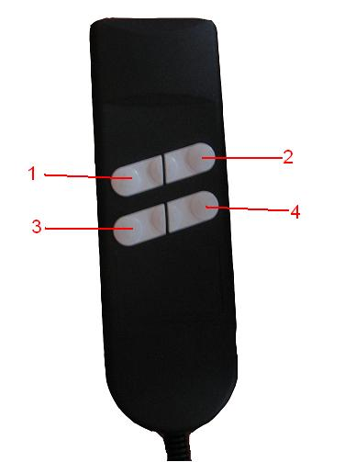
- If the hand control gets wet, unplug the transformer from the wall outlet and dry thoroughly before use. Ensure the hand control is out of the way before sitting in the chair.

- Up the backrest
- Up the seat and open up the footrest
- Down the backrest
- Down the seat and fold the footrest
Caution:
• If the circuit (controller) doesn’t work well, please contact the supplier.
• DON’T repair it by yourself in case of attainting the product and call the professional to repair it.
LIMITED WARRANTY:

ONE-YEAR LIMITED WARRANTY(LC-106)
For one(1) year from the date of purchase, Dalton will repair or replace at our option to the
original purchaser any of the following parts found upon examination by an authorized
representative of Dalton to be defective in material and/or workmanship:

• Wood Frame
• Motor
• Hand Control
• Scissor Mechanisms

WARRANTY EXCLUSIONS
This warranty does not extend to fabric and excludes steel frame chairs.

Dalton is not responsible or obligated to pay for labor, service calls, shipping, and/or any
other charges incurred for repair of the product. All transportation costs and shipping
damage incurred while submitting parts for repair or replacement are the responsibility of
the purchaser. Please contact your authorized Dalton Provider for information on the
current cost associated with a service visit.

• Circumstances beyond the control of Dalton.
• Labor, service calls, shipping, and other charges incurred for repair of the product, unless
specifically authorized, IN ADVANCE, by Dalton.
• Repairs and/or modifications made to any part without specific consent from Dalton.

Exclusions also include components with damage caused by:

• Contamination
• Abuse, misuse, accident, or negligence
• Battery fluid spillage or leakage
• Commercial use, or use other than normal
• Improper operation, maintenance, or storage

IMPLIED WARRANTIES
Implied warranties, including those of merchantability and fitness for a particular purpose,
and limited to one(1) year from the date of purchase and to the extent permitted by law. Any
and all implied warranties are excluded. This is the exclusive remedy. Liabilities for
consequential damages under any and all warranties are excluded.

Some states do not allow limitations on how long an implied warranty lasts or do not allow
the exclusion of limitation incidental or consequential damages. The above limitation or
exclusion may not apply to you.

This warranty gives you specific rights, and you may also have other rights which vary from
state to state.

Please fill out and return the product registration card to Dalton. This will aid Dalton in
providing the best possible technical and customer service.

We warrants its Fabric of Lift Chair will remain spill, moisture, bacteria and odor-free.
Punctures in the fabric are not covered under this warranty.

Nordbutiker I Sverige AB
76141 Norrtälje
08-522 309 80
info@blimo.se

